CENTRAL TENDENCY

Dataset:Placement.csv

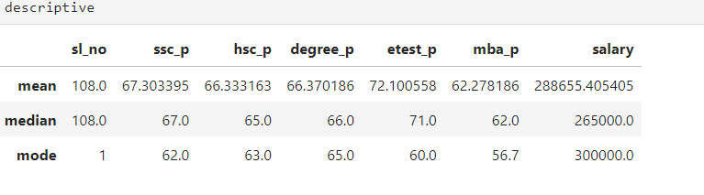MEAN
In our placement dataset, student has performed Average Range in SSC,HSC&DEGREE.Moreover ,They have gotton Above Average in ENTRANCE TEST.
MEDIAN
It ignores outlier.Compare with Mean ,the output is almost same.The only difference is salary, the difference between Mean & Median around Rs 2,36,135 .
MODE
Students got 62 mark in ssc,63 mark in hsc , 65 mark in degree,60 mark in entrance test & 56 mark in mba repeatedly.Moreover, Most of the employees has Rs3,00,000 salary.

